**Appendix J: Writing Questions and Exclamations Homework Page**

**Name:**

**Write one question.**

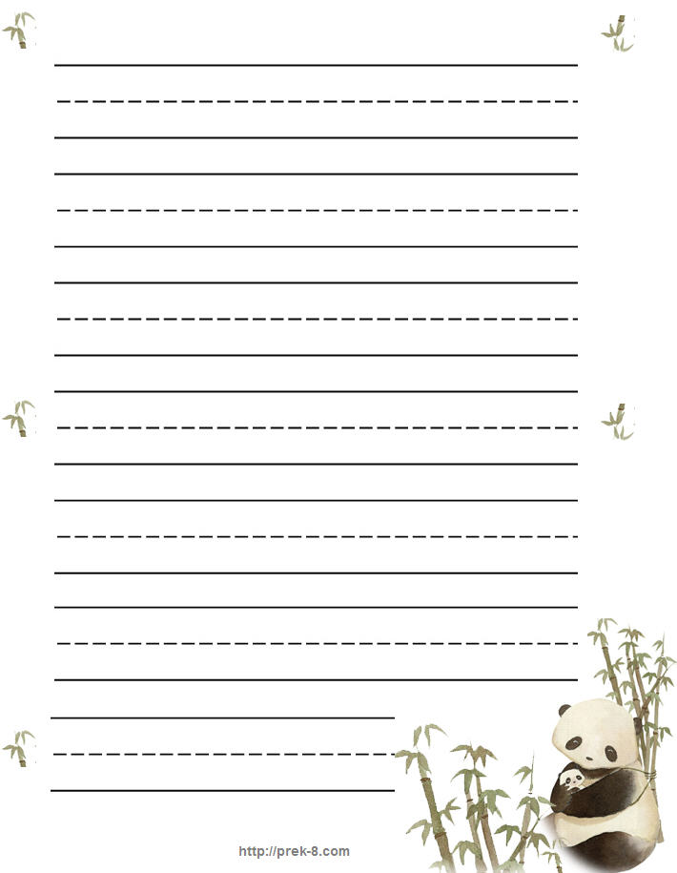

**Write one exclamation.**

